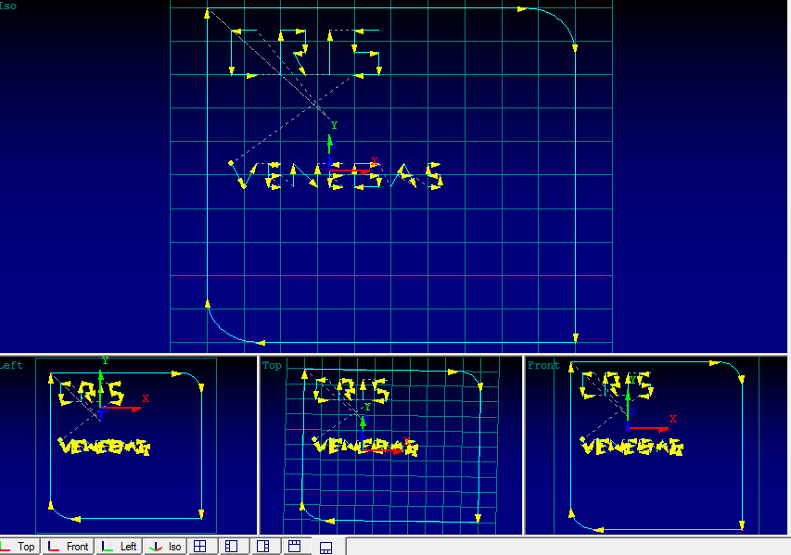

- O00(CRISTIAN2)
- G00 X-50. Y50.
- G01 X80. Y50.
- G02 X100. Y30.R20.
- G01 X100. Y-100.
- G01 X-30. Y-100.
- G02 X-50. Y-80. R20.
- G01 X-50. Y50.
- G00 X0. Y0.
- G00 X-30. Y40.
- G01 X-40.
- G01 Y20.
- G01 X-30.
- G00 X-20. Y20.
- G01 Y40.
- G02 Y40. X-10.
- G01 Y30.
- G01 X-15.
- G01 X-10. Y20.
- G00 X0. Y20.
- G01 Y40.
- G00 Y40. X20.
- G01 X10. Y40.
- G01 Y30.
- G01 X20. Y30.
- G01 Y20.
- G01 X10. Y20.
- G00 X-40. Y-20.
- G01 X-40.
- G01 Y-30. X-35.
- G01 X-35.
- G01 Y-20. X-30.
- G00 X-25.
- G01 X-20. Y-20.
- G01 X-25.
- G01 Y-30.
- G01 X-20.
- G00 X-25. Y-25.
- G01 X-20.
- G00 X-15. Y-30.
- G01 X-15. Y-20.
- G01 Y-30. X-5.
- G01 X-5. Y-20.
- G00 X5. Y-20.
- G01 Y-20. X0.
- G01 Y-30.
- G01 X5. Y-30.
- G00 Y-25. X0.
- G01 X5. Y-25.
- G00 X15. Y-25.
- G01 X20.
- G01 Y-30.
- G01 X10. Y-30.
- G01 Y-20.
- G01 X20.
- G00 Y-30. X25.
- G01 Y-20. X30.
- GO1 Y-30. X35.
- G00 X27. Y-25.
- G01 X33.
- G00 X40. Y-30.
- G01 X45.
- G01 Y-25.
- G01 X40.
- G01 Y-20.
- G01 X45.
- M30.
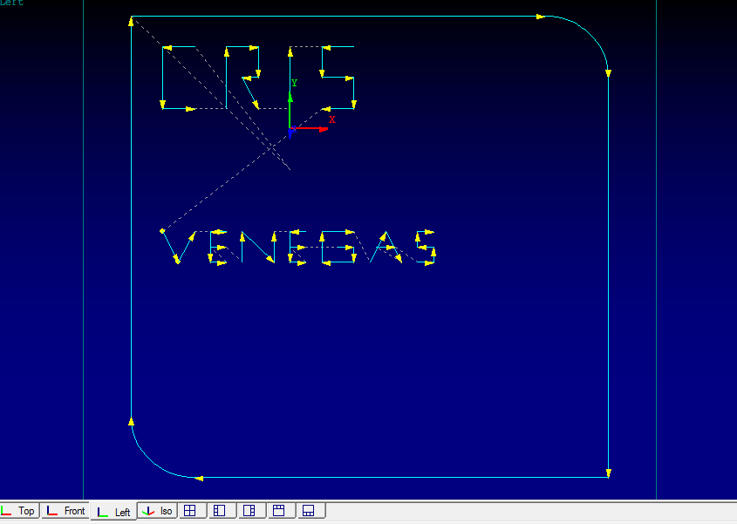
- M30

