T  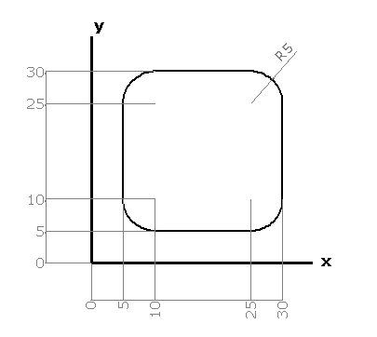 | 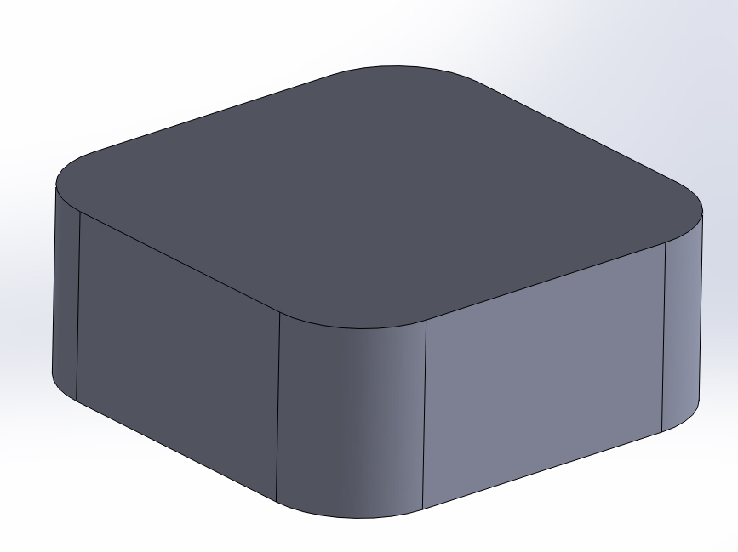

PROGRAMA ABSOLUTO  T01 G17  G00 Z10  G00 X0 Y0 G90  G00 X-10 Y-10 M03 F200 S500  G01 Z-10  G01 G42 X10 Y5  G01 X25  G03 I25 J10 W0  G01 Y25  G03 I25 J25 W90  G01 X10  G03 I10 J25 W180  G01 Y10  G03 I10 J10 W360  G00 Z100 M30 | PROGRAMA INCREMENTAL  T01 G17  G00 Z10  G00 X0 Y0 G91  G00 X-10 Y-10 M03 F200 S500  G01 Z-10  G01 G42 X20 Y15  G01 X15  G03 II5 IJ5 W0  G01 Y15  G03 II-5 IJ0 W90  G01 X-15  G03 II0 IJ-5 W180  G01 Y-15  G03 II5 IJ0 W360  G00 Z100 M30

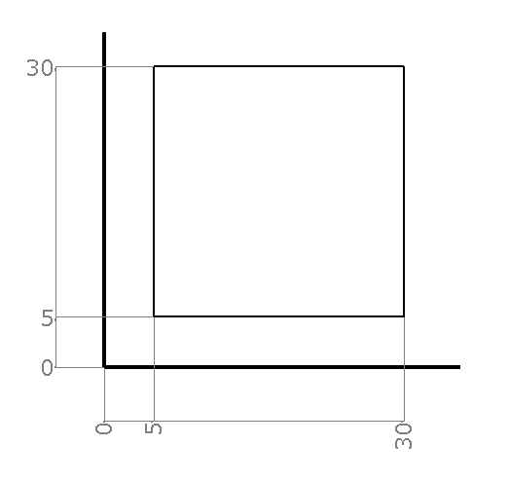 | 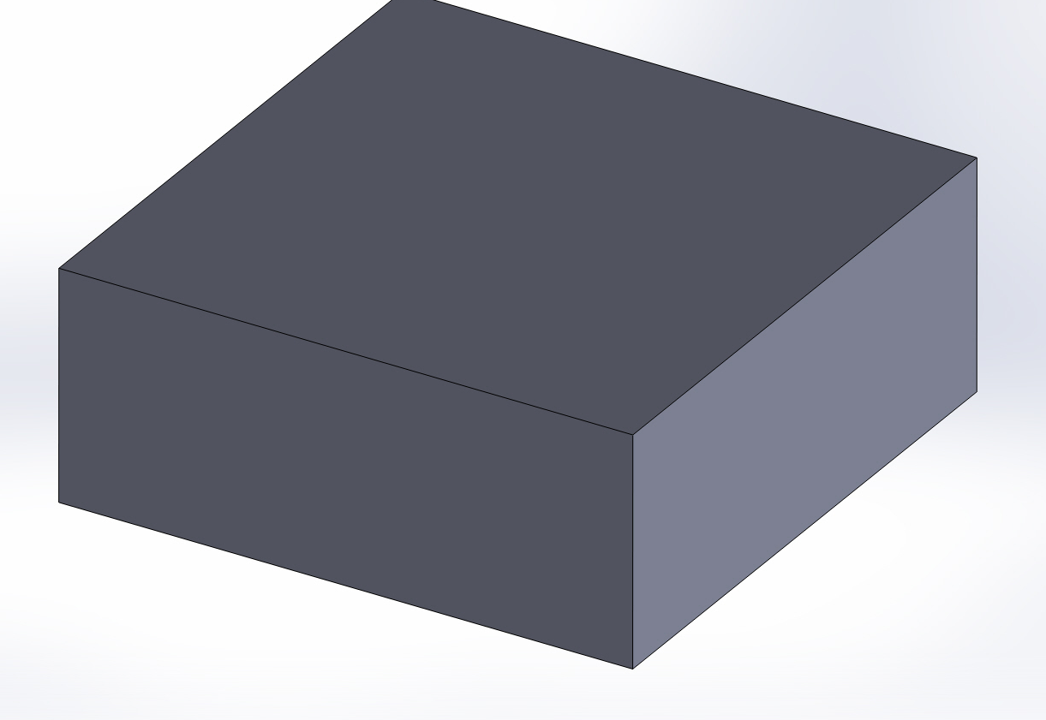

PROGRAMA ABSOLUTO  T01 G17  G00 Z10  G00 X0 Y0 G90  G00 X-10 Y-10 M03 F200 S500  G01 Z-10  G01 G42 X0 Y5  G01 X30  G01 Y30  G01 X5  G01 Y5  G00 Z100 M30 | PROGRAMA INCREMENTAL  T01 G17  G00 Z10  G00 X0 Y0 G91  G00 X-10 Y-10 M03 F200 S500  G01 Z-10  G01 G42 Y15  G01 X40  G01 Y25  G01 X-25  G01 Y-25  G00 Z100 M30

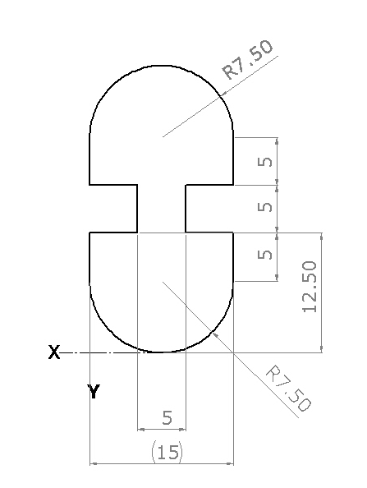 | 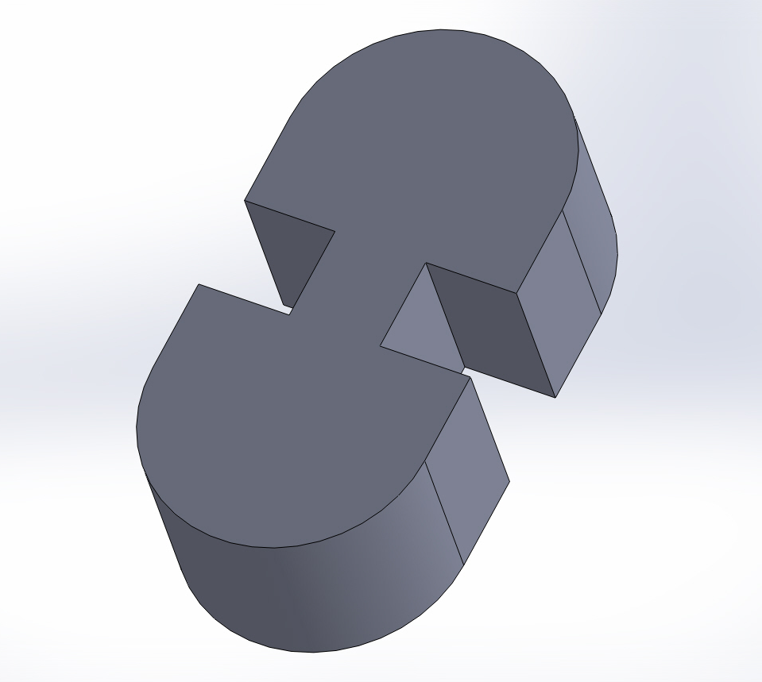

PROGRAMA ABSOLUTO  T01 G17( cristian)  G00 Z10  G00 X0 Y0 G90  G00 X-10 Y-10 M03 F200 S500  G01 Z-10  G01 G41 X0 Y0  G01Y12.5  G01 Y17.5  G01 X0  G01 Y22.5  G02 I7.5 J22.5 W0  G01 Y17.5  G01 X10  G01 Y12.5  G01 X15  G02 I7.7 J7,5 W180  G00 Z100 M30 | PROGRAMA INCREMENTAL  T01 G17  G00 Z10  G00 X0 Y0 G91  G00 X-10 Y-10 M03 F200 S500  G01 Z-10  G01 G42 X25  G01 Y22.5  G01 X-5  G01 Y5  G01 X5  G01 Y5  GO3 II-7.5 IJ0 W180  G01 Y-5  G01 X5  G01 Y-5  G01 X-5  G01 Y-5  G03 II7.5 IJ0 W0  G00 Z100 M30

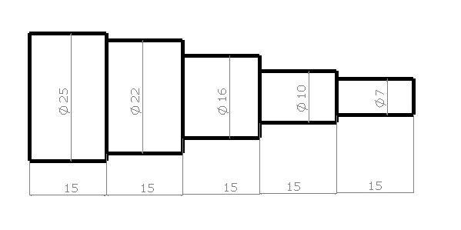 | 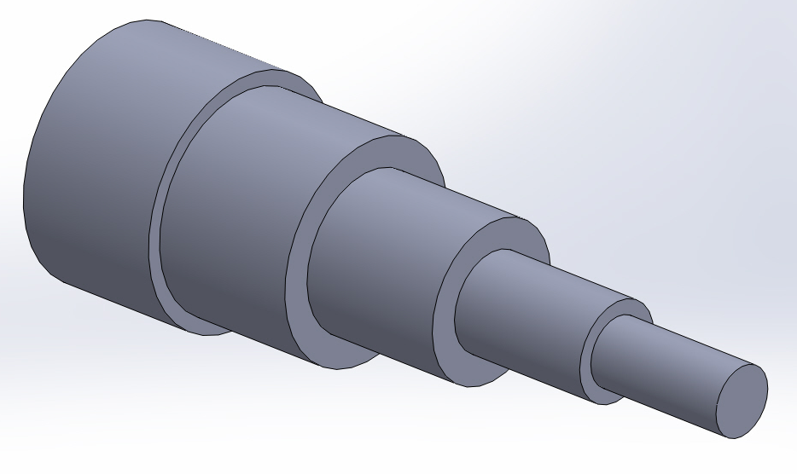

O00(cristian)
G00 X30 Z80
T01(PASADA)
M06
G90
G00 X0 Y0
G01 X25 Z75
G00 X30 Z80 T02 (PASADA)
G01 X24 Z75 M06
Z15
G00 Z75
G01 X23.5
Z15
G00 Z75
G01 X25
Z15
G00 Z75
G01 X22.5
Z15
G00 Z75
G01 X22.5
Z14
G00 Z75
G01 X22
Z15
G00 X30 Z80
T01 (3 PASADA)
M06G00 X21.5
Z30
G00 Z75
G01 X21
Z30
GOO Z75
G01 X21
Z30
G00 Z75
G01 X20.5
Z30
G00 Z75
G01 X20
Z30
G00 Z75
G01 X19.5
Z30
G00 Z75
G01 X10
Z30
G00 Z75
G01 X18.5
Z30
G00 Z75
G01 X18
Z30
G01 Z75
G01 X17.5
Z30
G00 Z75
G01 X17
Z30
G00 Z75
G01 X17
Z30
G00 Z75
G01 X16.5
Z30
G00 Z75
G01 X16.5
Z30
G00 Z75
G01 X16
Z30
G00 X50 Z80
T01 (PASADA)
M06
G00 X16 Z75
G01 X15.5
Z45
G00 Z75
G01 X25
Z 45
G00 Z75
G01 X13.5
Z45
G00 Z75
G01 X13
Z45
G00 Z75
G01 X13.5
Z45
G00 Z75
G01 X13
Z45
G01 X12.5
Z45
G00 Z75
G01 X12
Z45
G00 Z75
G01 X11
Z45
G00 Z75
G01 X13
Z45
G01 X12.5
Z45
G00 Z75
G01 X12
Z45
G00 Z75
G01 X11.5
Z45
G00 Z75
G01 X11
Z45
G00 Z75
G01 X10.5
Z45
G00 Z75
G01 X10
Z45
G00 X30 Z80
T5 (PASADA)
M06
G00 X10 Z75
G01 X45
Z60
G00 Z75
G01 X9
Z60
G00 Z75
G01 X8.5
Z60
G00 Z75
G01 X8
Z60
G00 Z75
G01 X7.5
Z60
G00 Z75
G01 X7 Z60 M30

